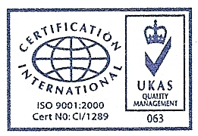ERIC WONG MACHINERY TRANSPORTATION PTE LTD
No. 30, Defu Lane 7, Singapore 539347
Tel: 62824175, 62828203, 62826020, Fax: 62865602
GST Reg No. : M2-8923804 – 2
http://www.ericwong.com
e-mail: ewmtpl@gmail.com

Full Name | NRIC | Nationality | Company | Vehicle No
Jamari Bin Md Sain | SXXXX736H | Singaporean | Eric Wong Machinery
Abdul Samad Bin Ahmad | SXXXX898C | Singaporean | Eric Wong Machinery
Abdul Rahman Bin Mohamed | SXXXX274A | Singaporean | Eric Wong Machinery
Sa’aban Bin Abu Bakar | SXXXX913Z | Singaporean | Eric Wong Machinery | GBD 9415 H
Lim Boon Lay | SXXXX987B | Singaporean | Eric Wong Machinery | XB 8809 L
Ngaimin Bin Sudarjo | SXXXX742Z | Singaporean | Eric Wong Machinery | XD 4026 U
Md Rizal Bin Hasali | SXXXX207G | Singaporean | Eric Wong Machinery

